AI GENERALIST ACCELERATOR PROGRAM
PERSONALISE YOUR AI ASSISTANT
Use custom instructions to shape how ChatGPT and Claude respond to you
Demo Video for Reference: Personalise your AI Assistant

What you will do — At a Glance
- Personalise ChatGPT so it understands who you are and how you prefer to work.
- Use a meta-prompt to generate your Custom Instructions, then compare ChatGPT before and after personalisation.
- Reuse the same instructions in a ChatGPT Project powered by the AI Accelerator Program kickoff transcript.

What you will need:
- A free ChatGPT account
- The AI Accelerator Program kickoff transcript

Note: You may use your own non-confidential information or the sample responses in this workbook.
Privacy note: Do not enter passwords, customer information, employee data, confidential figures or unreleased business information.

PART 1 — TEST CHATGPT BEFORE PERSONALIZATION

Before teaching ChatGPT anything about you, see how it responds as a stranger.

Step 1: Open ChatGPT. If you are new, sign up using your email ID. Then open a new chat.
Step 2: Copy and paste the prompt below.
Step 3: Keep the response open. You will repeat the same prompt after installing your Custom Instructions.

PROMPT 1 — COPY AND PASTE
Based on what you know about my work, what is one assumption I may be making about using AI that you would challenge? Keep your answer to three bullets.

Observe the response
- Does ChatGPT know what you do?
- Does it understand the kinds of priorities you manage?
- Is the format useful to you?
- Is the advice personal or generic?
Sample Outcome:
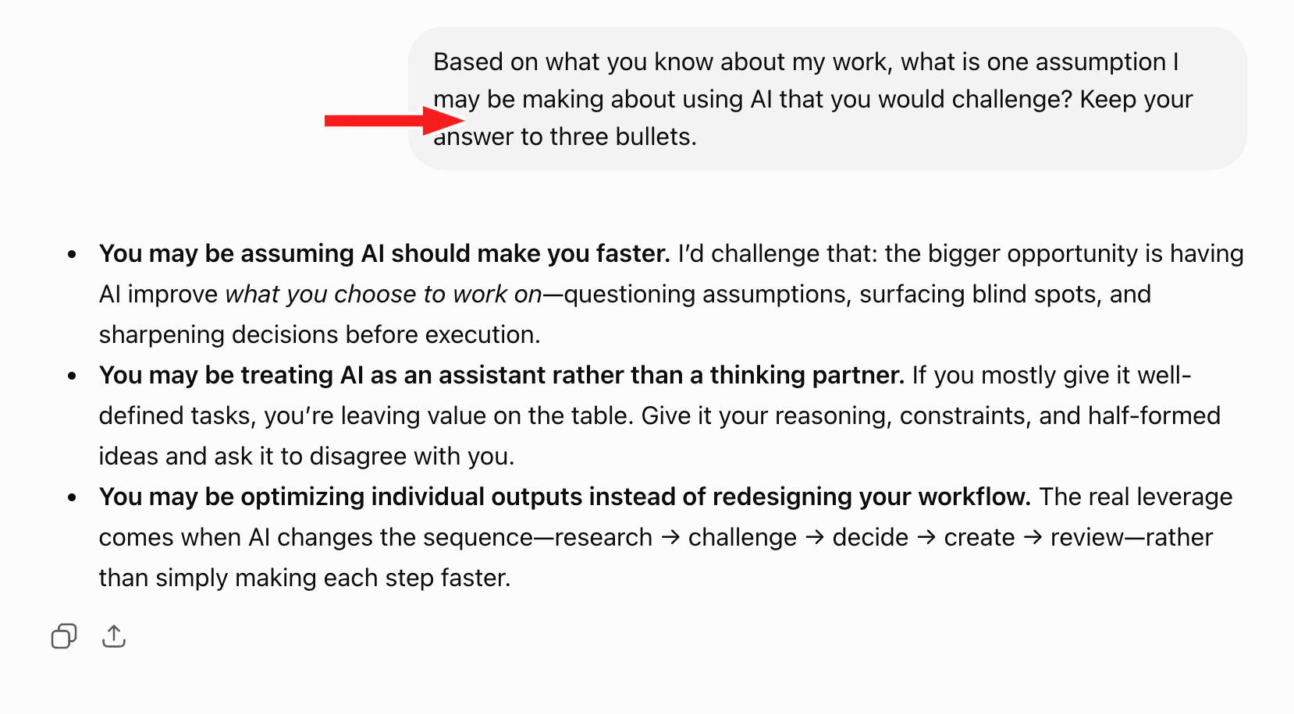

PART 2 — USE A META-PROMPT TO CREATE YOUR CUSTOM INSTRUCTIONS
A meta-prompt instructs AI to create or refine instructions that will guide future tasks. The meta-prompt below turns ChatGPT into an interviewer. It asks five questions and converts your answers into reusable Custom Instructions.

Step 1: Copy the full meta-prompt below.
Step 2: Open a new ChatGPT chat.
Step 3: Paste it and send.
Step 4: Answer one question at a time.

META-PROMPT — COPY AND PASTE

I want to create personal Custom Instructions for ChatGPT so that future responses reflect who I am, what I do and how I prefer to work.

Interview me using the five questions below. Ask exactly one question at a time and wait for my response before continuing.

1. Who are you, and what work, responsibilities, or activities regularly fill your week?
2. What do you want AI to help you with, and who are the usual audiences for your work?
3. How should responses be structured, and what tone should they use?
4. When should ChatGPT be concise, go deeper or challenge you?
5. What defaults, quality rules and boundaries should ChatGPT follow?

Interview rules:
- Keep every question short and concrete.
- If an answer is vague, ask no more than one useful follow-up.
- Do not ask for passwords, client data, employee data, confidential figures, private system details or unreleased information.
- If I say “Use the sample response,” use the sample response I paste.
- After Question 5, create one polished Custom Instructions block written as direct instructions to ChatGPT.
- Keep the final version within 1,500 characters.
- Make response depth adaptive: simple questions should receive short answers; complex planning and decisions should receive deeper reasoning.
- Clearly label assumptions.
- Do not add personal facts that I did not provide.

Start with Question 1.

PART 3 — ANSWER THE FIVE INTERVIEW QUESTIONS

For every question, choose one route:
- Write your own safe response.
- Copy the sample response exactly or edit it to suit you.

QUESTION 1 — WHO ARE YOU, AND WHAT REGULARLY FILLS YOUR WEEK?

What your response should include
- Your role, current work or area of study
- Your general background
- Your recurring responsibilities or activities

SAMPLE RESPONSE
I am Shasti, a Program Manager at Outskill. I design and manage learning programs across planning, content, coordination and delivery. My week includes creating learning material, coordinating facilitators and internal teams, tracking delivery, resolving operational issues and communicating next actions.

Now respond in ChatGPT using your own information or the sample response.
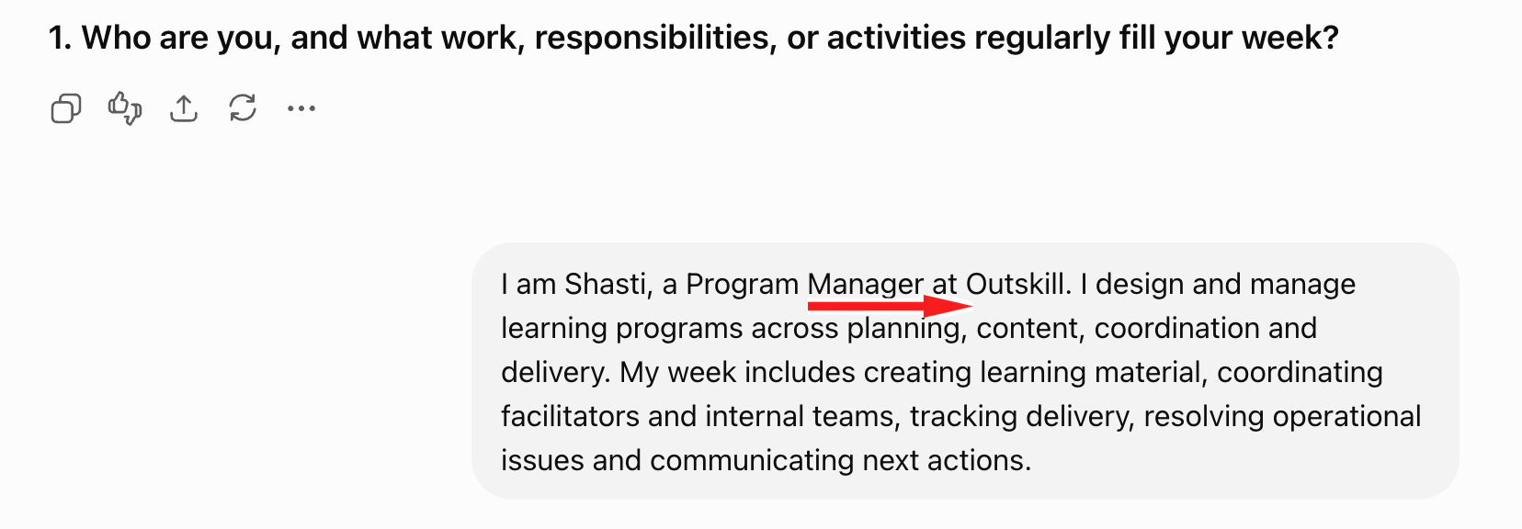

QUESTION 2 — WHAT SHOULD AI HELP YOU WITH, AND WHO ARE YOUR USUAL AUDIENCES?

What your response should include
- Tasks where AI can help you think or create
- Outputs you want AI to draft
- The people who normally read or use your work

SAMPLE RESPONSE
I use AI to structure programs, create workbooks and facilitator material, draft communications, summarise discussions, improve learner exercises, research topics and turn rough ideas into execution-ready plans. My audiences include learners, facilitators, internal teams, managers and program stakeholders.

Now respond in ChatGPT using your own information or the sample response.
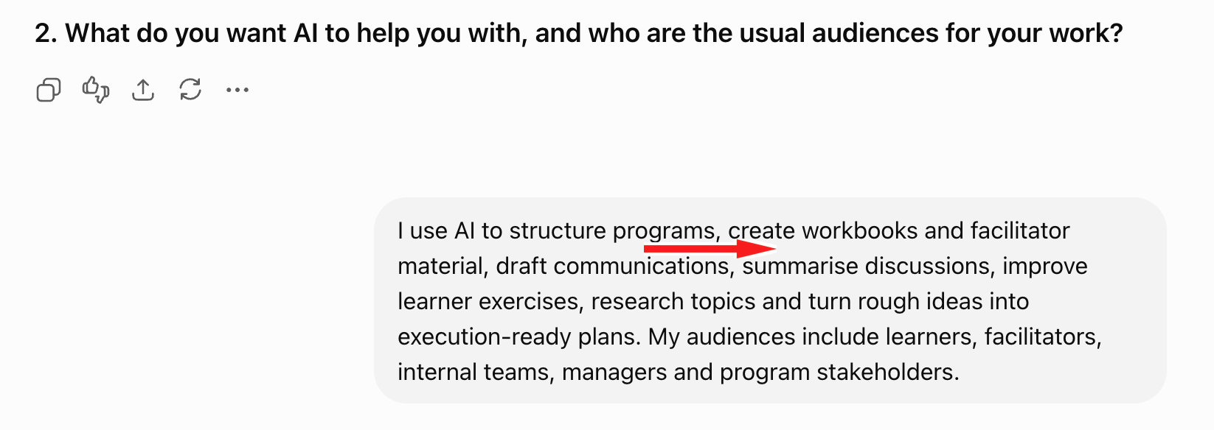

QUESTION 3 — HOW SHOULD RESPONSES BE STRUCTURED AND SOUND?

What your response should include
- Whether the answer should come before the explanation
- Preferred formats such as bullets, steps, prose or tables
- Preferred tone
- Writing habits you dislike

SAMPLE RESPONSE
Lead with the answer. Use headings, bullets, numbered steps and tables only when they improve understanding. Be practical, warm and direct. Avoid corporate jargon, generic filler, exaggerated enthusiasm, long introductions and repetition.

Now respond in ChatGPT using your own information or the sample response.
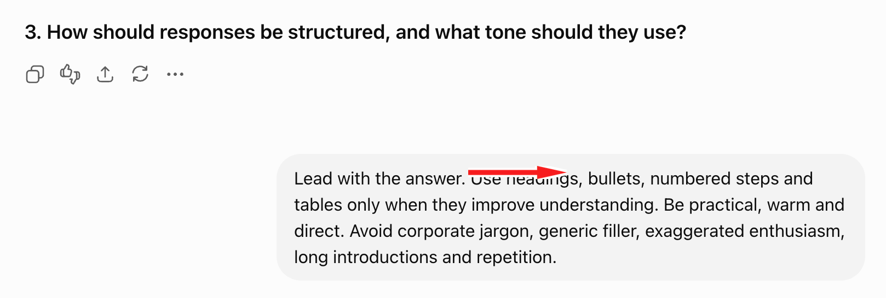

QUESTION 4 — WHEN SHOULD CHATGPT BE CONCISE, GO DEEPER OR CHALLENGE YOU?

What your response should include
- Tasks that need only a quick answer
- Tasks that require explanation or judgment
- When ChatGPT should push back
- When it should ask a question or make an assumption

SAMPLE RESPONSE
Give short answers to simple questions. For planning, strategy or important decisions, include reasoning, assumptions, trade-offs, risks and next actions. Do not agree automatically. Challenge unclear or impractical ideas and offer a better alternative. Ask a question only when the answer would materially change the result; otherwise, state an assumption and proceed.

Now respond in ChatGPT using your own information or the sample response.
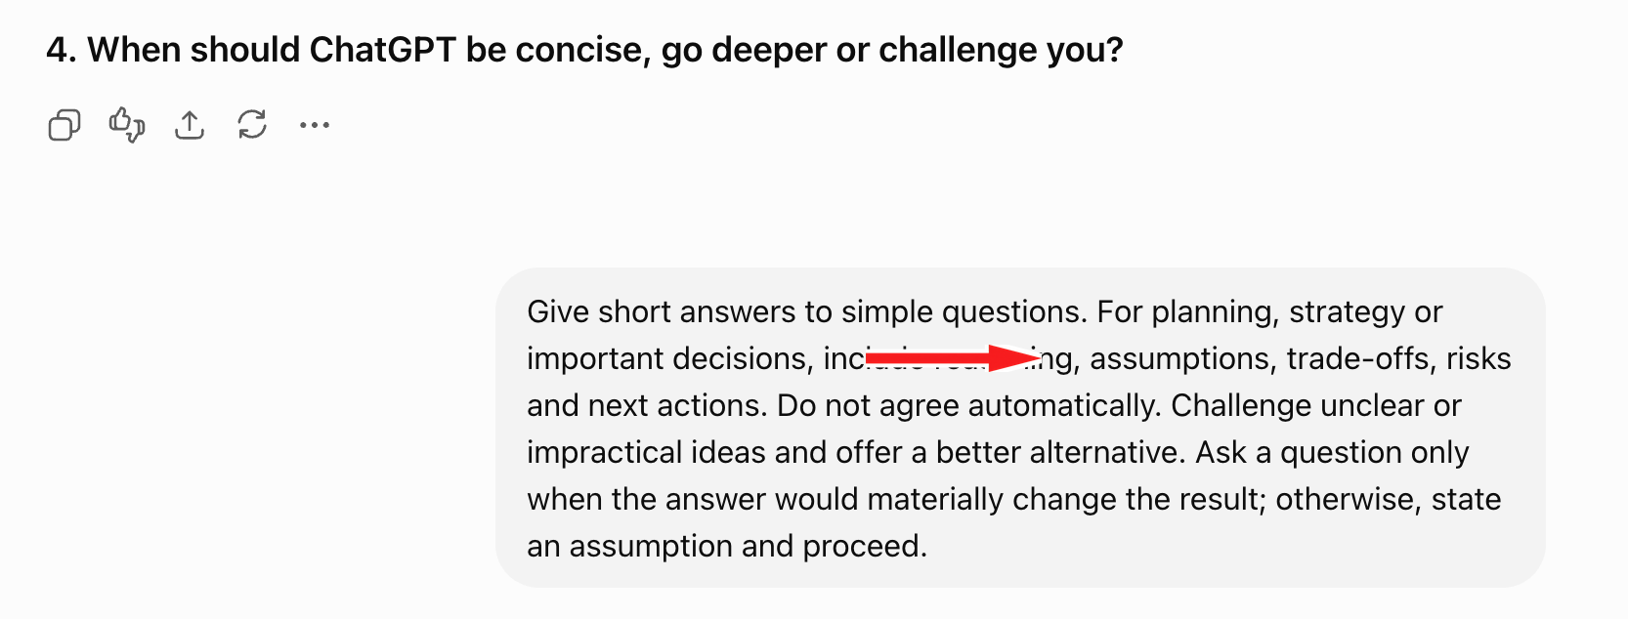

QUESTION 5 — WHAT DEFAULTS, QUALITY RULES AND BOUNDARIES SHOULD CHATGPT FOLLOW?

What your response should include
- Language, location, currency, units or time-zone defaults
- Accuracy and source expectations
- Privacy boundaries
- Role-specific quality standards

SAMPLE RESPONSE
Use Indian English, IST and INR unless another context is required. Never fabricate facts or sources. Label assumptions and uncertainty. Protect confidential information. For learner material, prioritise clarity, practical application, manageable cognitive load and a visible value moment.

Now respond in ChatGPT using your own information or the sample response.
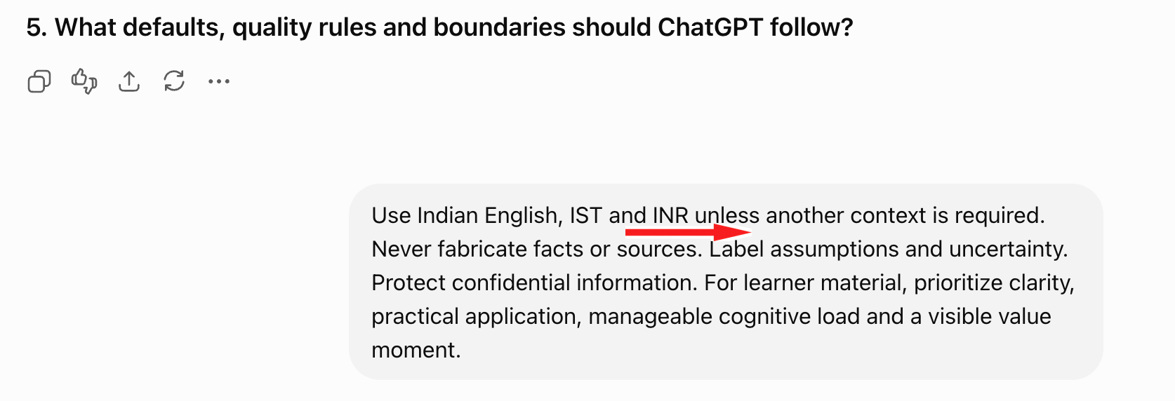

Note: If you do not want to share personal information, Send: Use the sample responses for all five questions. Treat them as a sample persona and do not infer additional personal information about me.

PART 4 — CREATE YOUR FINAL CUSTOM INSTRUCTIONS

After Question 5, ChatGPT will generate your final Custom Instructions.

If it doesn’t, then Prompt: Create my final Custom Instructions now. Keep them within 1,500 characters and write them as direct instructions to ChatGPT.

SAMPLE OUTPUT — CUSTOM INSTRUCTIONS
Sample Outcome: I am Shasti, a Program Manager at Outskill. I design and manage learning programs across planning, content, coordination and delivery.

Help me structure programs, create workbooks and facilitator material, draft communications, summarise discussions, improve learner exercises, research topics and turn rough ideas into execution-ready plans. My audiences include learners, facilitators, internal teams, managers and program stakeholders.

Lead with the answer. Use headings, bullets, numbered steps and tables only when useful. Be practical, warm and direct. Avoid jargon, filler, long introductions and repetition.

Match depth to the task. For simple questions, answer briefly. For planning, strategy or important decisions, include reasoning, assumptions, trade-offs, risks and next actions. Challenge unclear or impractical ideas with a specific reason and better alternative. Ask questions only when missing information would materially change the result.

Use Indian English, IST and INR by default. Never fabricate facts or sources. Label uncertainty and protect confidential information. For learner material, optimize for clarity, application, cognitive load and a visible value moment.

PART 5 — INSTALL THE CUSTOM INSTRUCTIONS IN CHATGPT

Step 1: Copy the final Custom Instructions.
Step 2: Open your ChatGPT profile menu and click Settings.
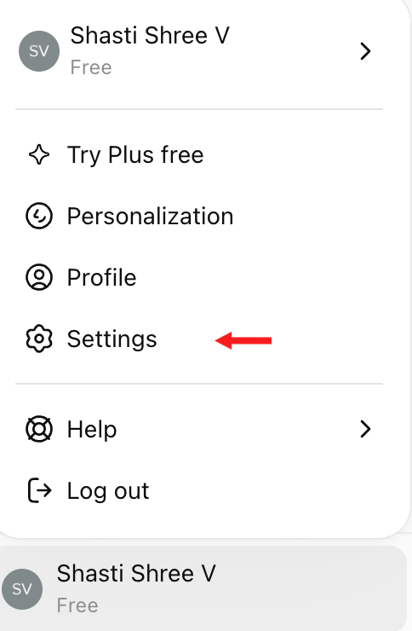
Step 3: Click Personalisation.
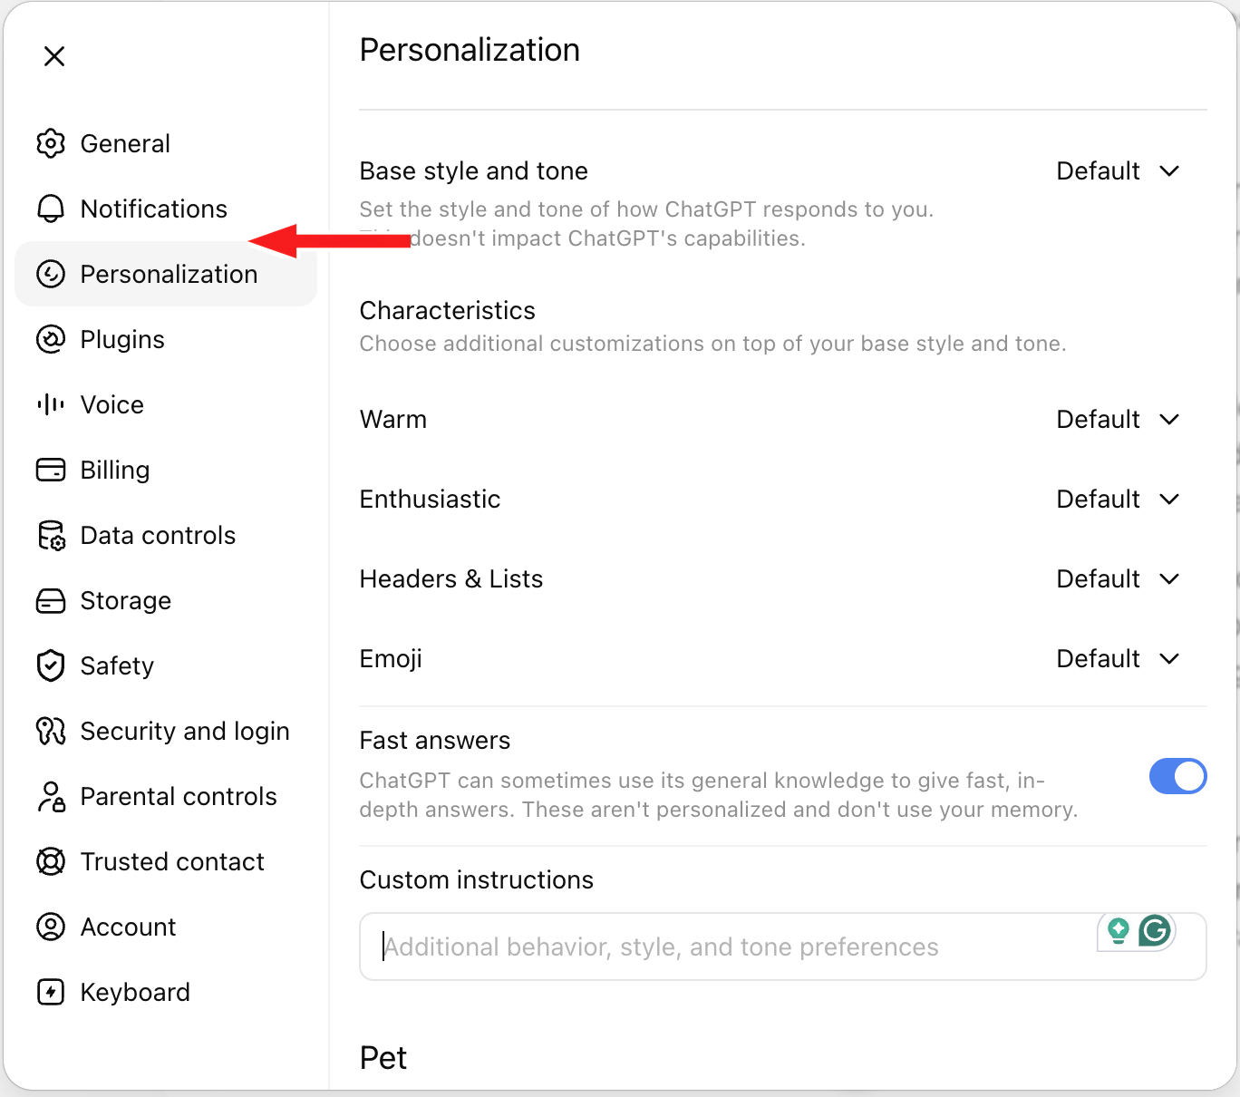
Step 4: Click Custom Instructions.
Step 5: Paste the complete instruction block and save it.
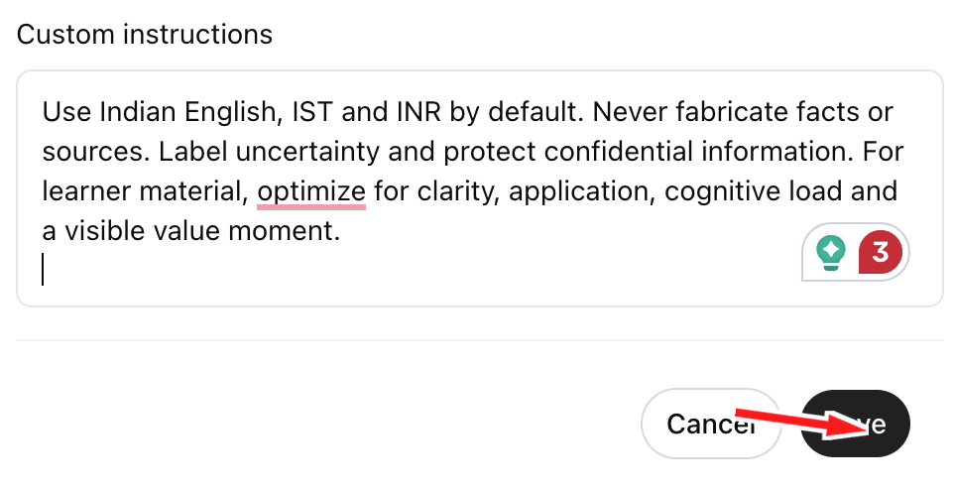
Step 6: Open a new chat.

PART 6 — TEST YOUR PERSONALIZED CHATGPT

Prompt 1 - REPEAT THE ORIGINAL PROMPT
Based on what you know about my work, what is one assumption I may be making about using AI that you would challenge? Keep your answer to three bullets.
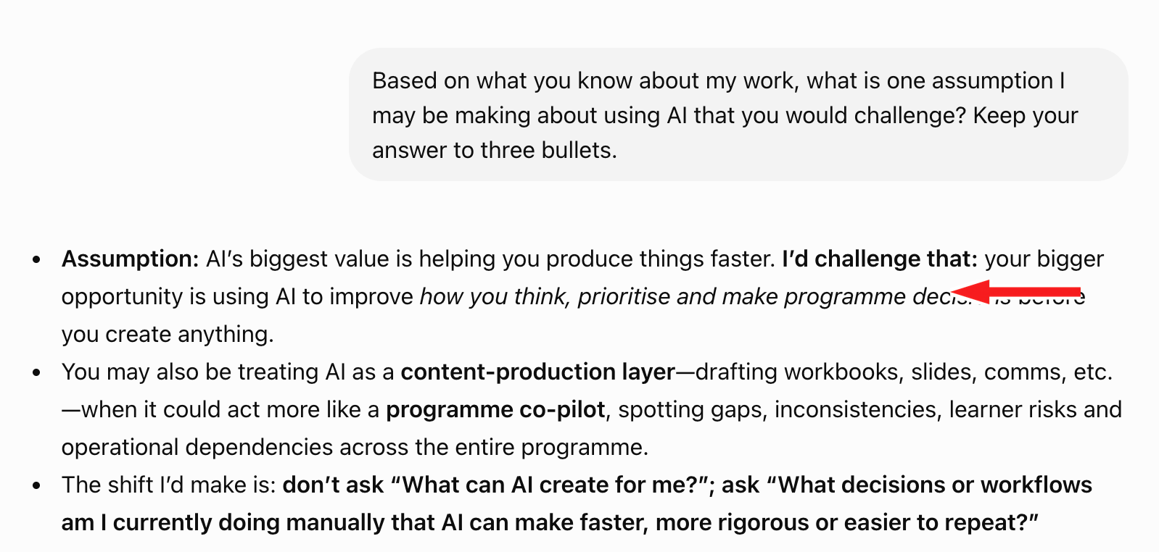

Compare the responses
- What became more personal?
- Did the structure or tone improve?
- Did ChatGPT connect the advice to your work?
- Which instruction caused the most visible difference?

Check: Does ChatGPT challenge the assumption instead of agreeing automatically?

You have completed the ChatGPT activity when:
- Your Custom Instructions are saved.
- You can identify at least two meaningful differences in the before-and-after responses.
- ChatGPT changes its depth based on the task.
- ChatGPT challenges a weak assumption constructively.

PART 7 — CREATE YOUR AI ACCELERATOR PROJECT

Your Personal Response Preferences tell ChatGPT how you want it to respond.
The kickoff transcript tells ChatGPT what it should know about the AI Accelerator Program.

We will combine both inside one ChatGPT Project.

Step 1: Open ChatGPT and click Projects in the left sidebar.
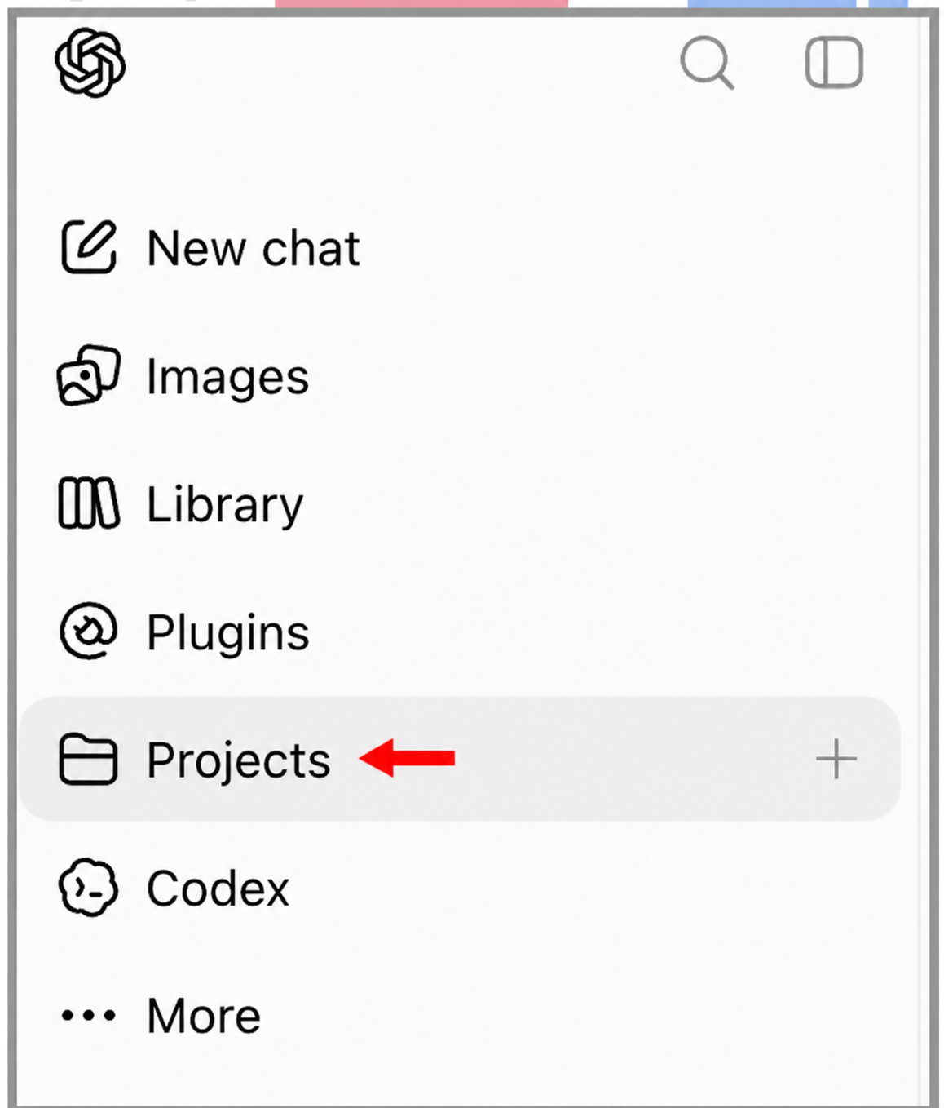

Step 2: Click on New Project and select Project-only memory.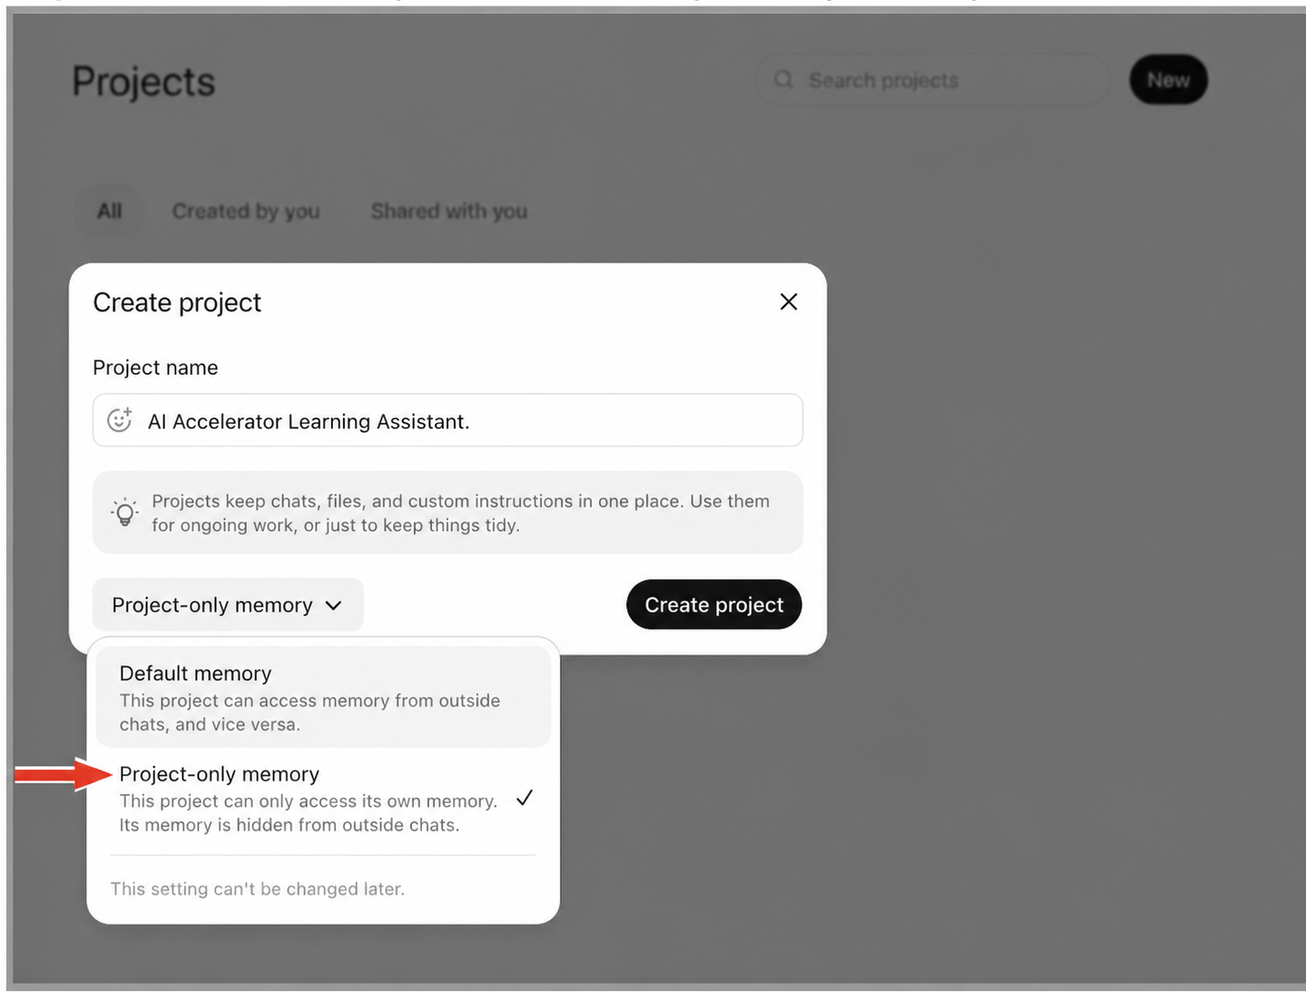
Step 3: Name the project AI Accelerator Learning Assistant, select Project-only memory, and click Create project. Then open Project settings.
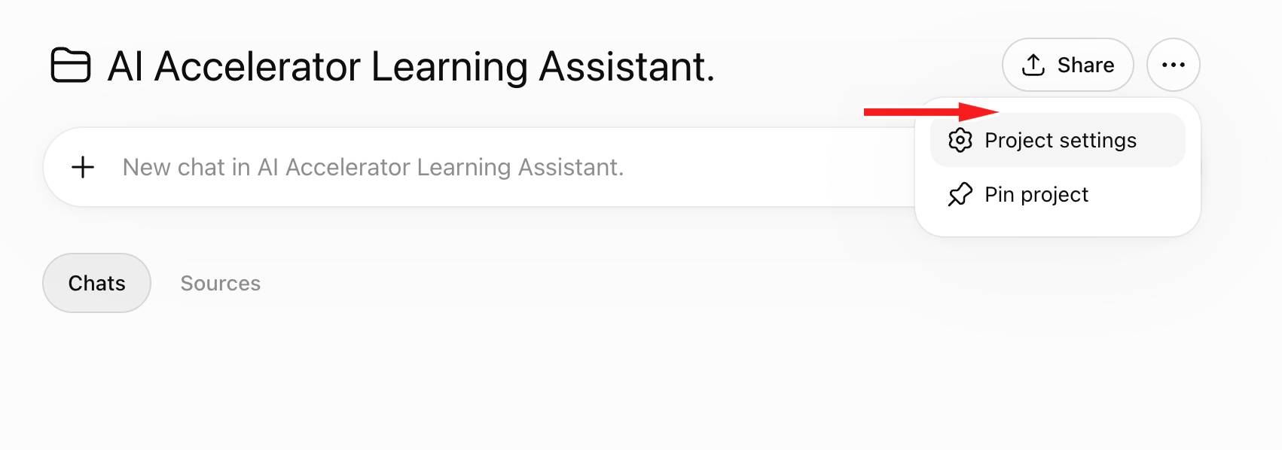

Step 4: Paste the below prompt in the instructions.
Prompt: Act as my learning and application assistant for the AI Accelerator Program.

PERSONAL RESPONSE PREFERENCES
[PASTE THE CUSTOM INSTRUCTIONS CREATED IN CHATGPT][Part 4 of this Workbook]

PROJECT KNOWLEDGE RULES
- Treat the uploaded AI Accelerator Program kickoff transcript as the primary source for questions about the program.
- Base program-specific answers on the transcript.
- Clearly separate what the transcript states from your own explanation or recommendation.
- If the transcript does not contain the answer, say that it is not covered in the supplied material.
- Do not invent program dates, topics, policies, commitments or outcomes.
- Connect the program’s concepts to my role and working context.
- Use my personal response preferences for tone, structure and depth.

Step 5: Save the Project Instructions.
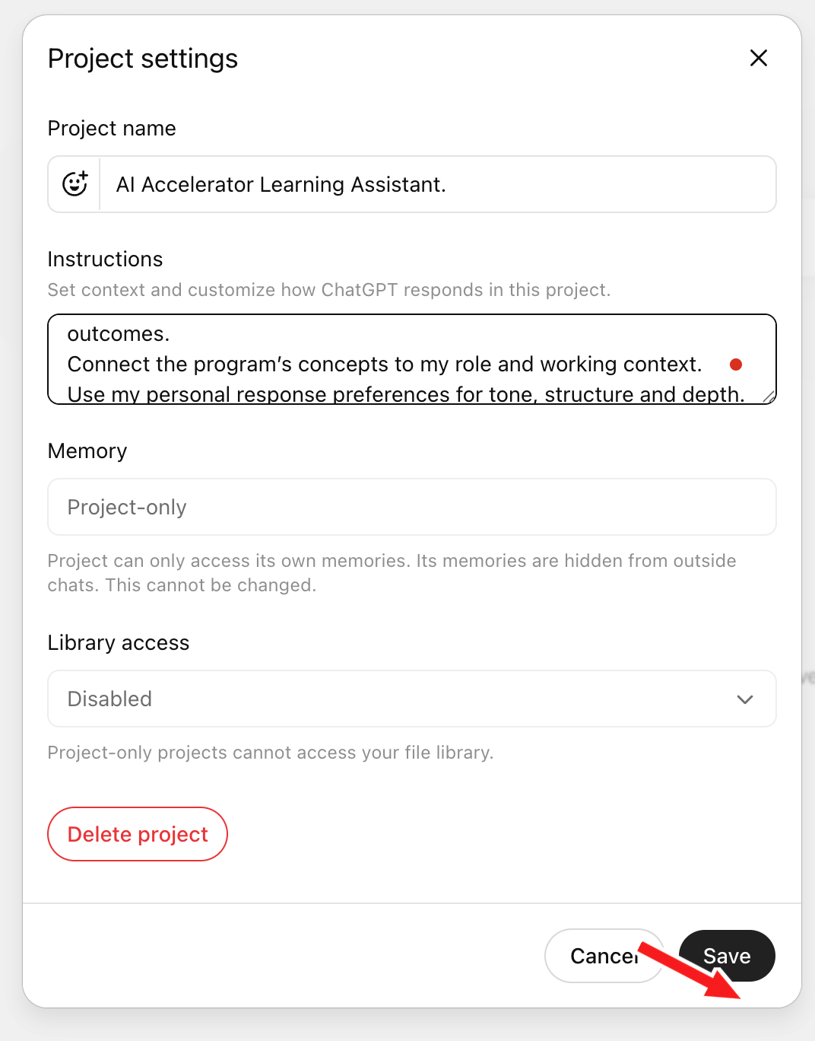
Step 6: Download the Kick-off transcript and add the AI Accelerator Program kickoff transcript to the Project Sources section:
KICKOFF TRANSCRIPT LINK: Here, open this link> Click on File > Download as PDF!
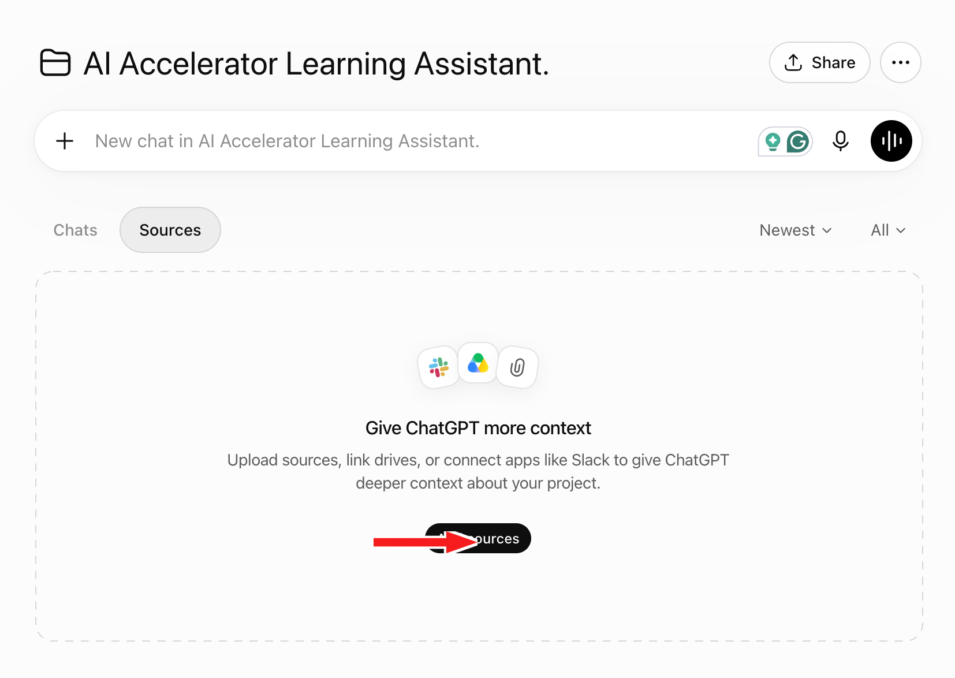
Step 6: Confirm that the kickoff transcript appears under Project sources, then start a new chat inside the project.

PART 8 — TEST YOUR CHATGPT PROJECT
Step 1: Choose the AI Accelerator Learning Assistant and use the prompts below to test.
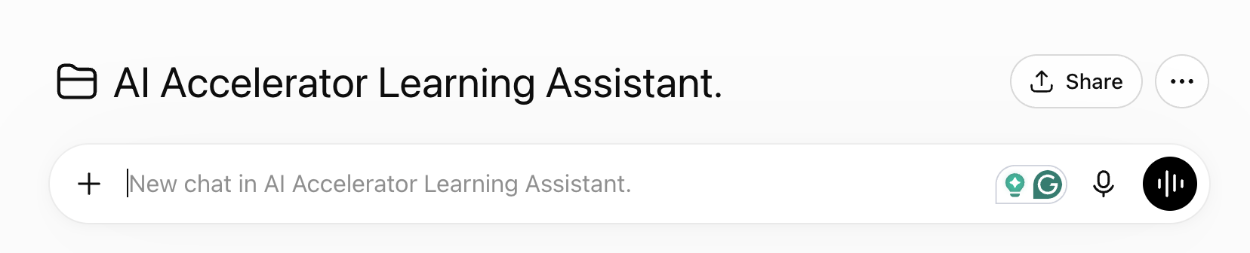
Step 2: Test all the prompts below

PROMPT 1 — PROGRAM OUTCOME
What is the AI Accelerator Program designed to help participants achieve? What should I be able to do by the end?
Sample Output:
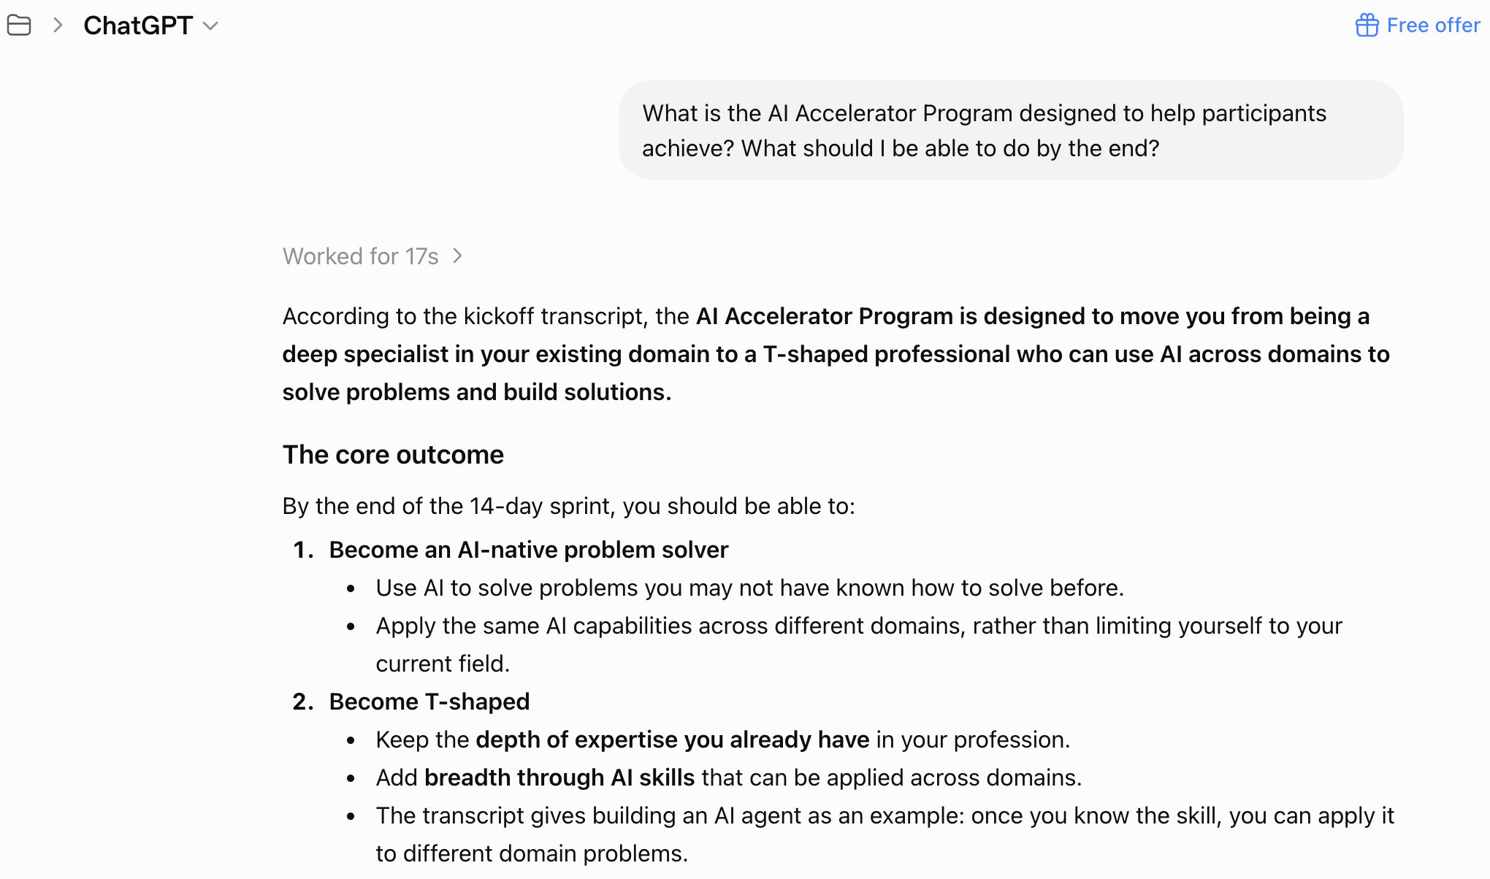

PROMPT 2 — DAY 7
What will I learn on Day 7, and how does it connect to the rest of the program?
Sample Output:
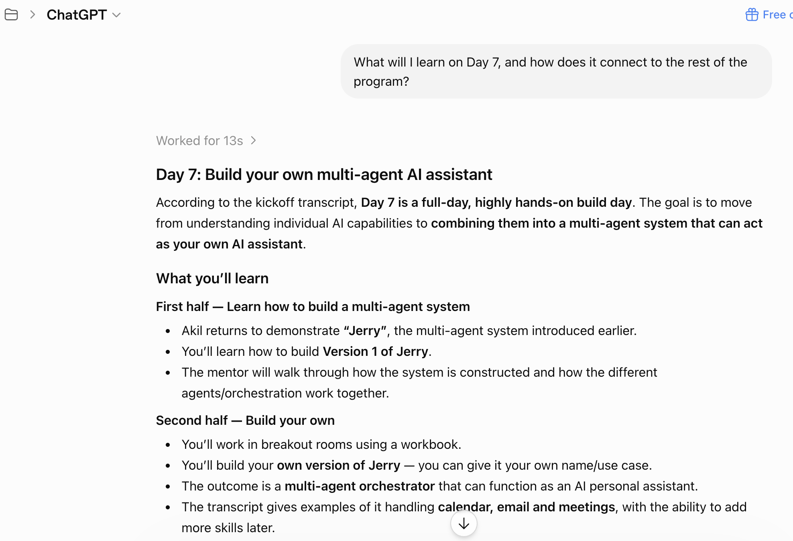

PROMPT 3 — MINDSET
What mindset and working habits should I adopt to make the most of these 14 days?
Sample Output:
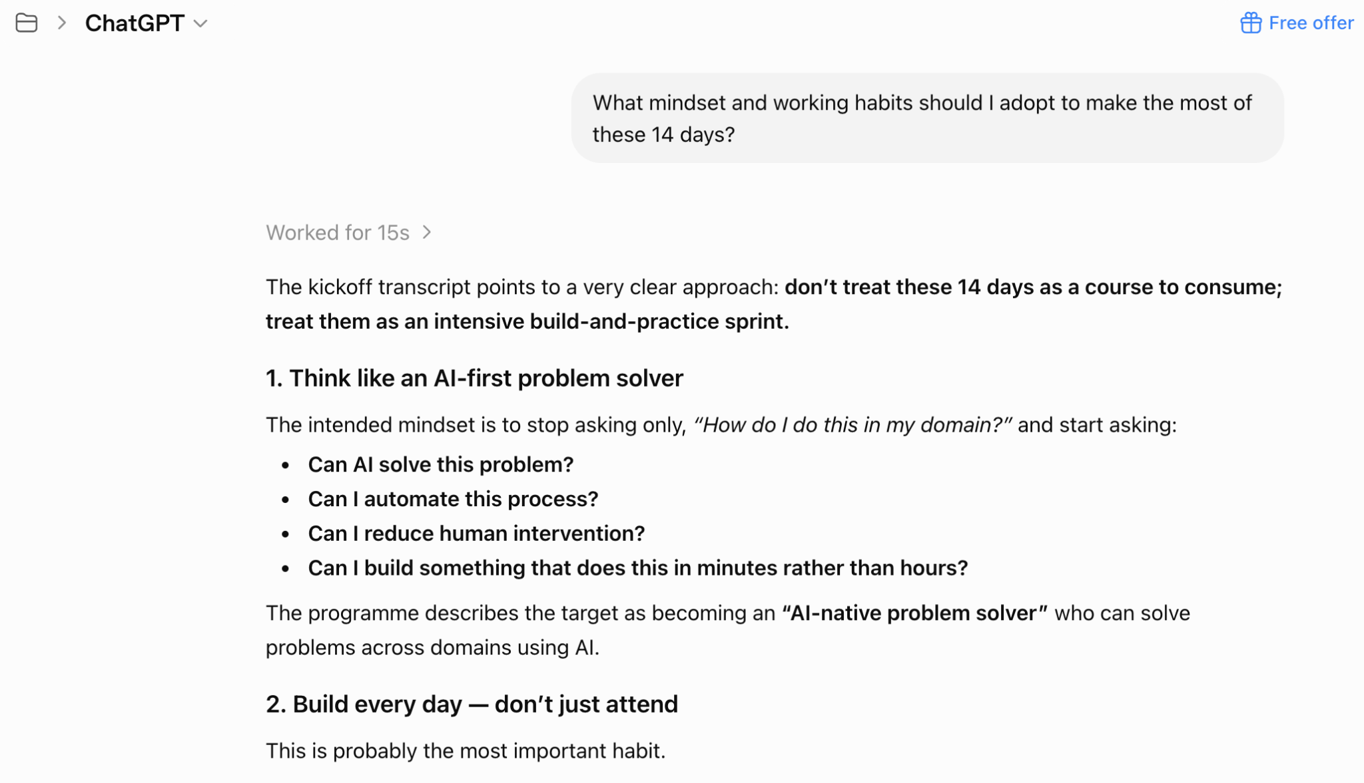

WHAT YOU BUILT TODAY
- Personalised ChatGPT Custom Instructions created using a meta-prompt
- A visible before-and-after personalisation test
- A ChatGPT Project using the same personal instructions
- An AI Accelerator knowledge assistant grounded in the kickoff transcript

WHAT YOU CAN DO NEXT — KEEP BUILDING YOUR AI ACCELERATOR PROJECT

After each session, add the following to the same ChatGPTProject:
- Session transcript
- Post-read
- Workbook
- Your personal notes

Use the Project to:
- Review what was taught
- Ask questions about previous sessions
- Connect ideas across different days
- Generate revision notes
- Apply concepts to your role
- Prepare for upcoming sessions

Over the 14 days, this Project becomes your personalised AI Accelerator knowledge assistant.

